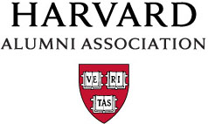

What does the HAA do?
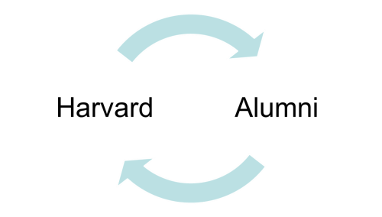

The HAA promotes the welfare of Harvard University and the establishment of a mutually beneficial relationship between Harvard University and its alumni.

What is the mission of the HAA Board?

The HAA Board of Directors exists to foster alumni community building and to create University citizens of our alumni volunteers and alumni broadly.

Why does it matter?

A healthy university has deeply engaged alumni who support the institution, work as ambassadors, protect and steward the brand, and serve as important volunteers.
How do we measure engagement?
Traditionally, alumni engagement has been measured by behaviors (event attendance, giving, address updates, etc.). We believe it is equally important for us to consider and measure how alumni feel about their connection to the University.
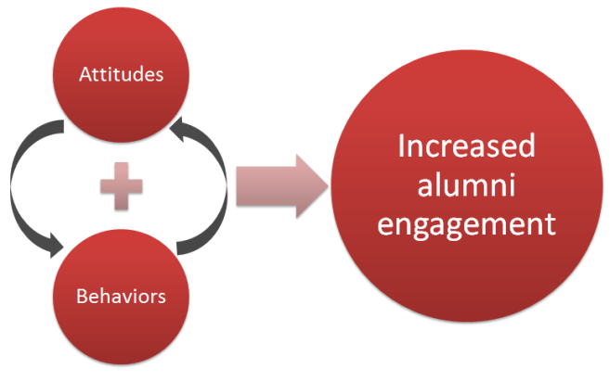

Positive experiences in either arena will naturally and positively affect the other. Over time, this could have a cumulative impact on increased alumni engagement.

Alumni Engagement Research
The HAA conducted an alumni engagement survey to a representative sample of our community in the summer of 2012, and the learnings from that survey have helped inform and guide our work across the staff and volunteer groups. In November 2014, we undertook an updated or “pulse” survey.

Results are extensive, and the data has helped inform Board initiative and committee charters. You, as volunteer leaders, will again be essential in helping turn what we have learned from these new findings into action.

Overall: What have we learned about attitudes?
We used four questions to determine alumni attitudes. Each question ranged from 1-6, negative to positive. The answers to those questions formed an index we call the Alumni Engagement Index or AEI. The questions:
- How would you describe your feelings toward Harvard as a whole?
- How connected do you feel to Harvard as a whole?
- How satisfied are you with your experience with Harvard as an alumnus/na?
- To what extent do you agree or disagree: I feel part of the Harvard alumni community?

The Alumni Engagement Index (AEI)

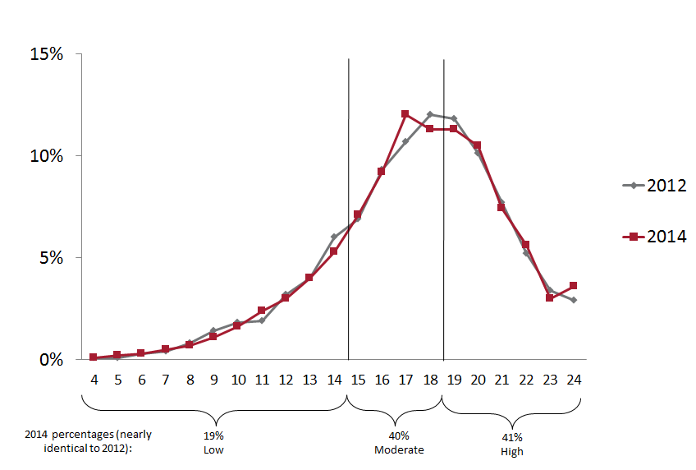
 | 2014 results | 2012 results
High engagement | 41% | 41%
Mid engagement | 40% | 39%
Low engagement | 19% | 20%

The good news:
- Roughly twice as many alumni are considered highly engaged as low
- Our sense of community (question 4) has increased
- Harvard Club membership is a good predictor of high engagement
- Alumni have an increasing sense that Harvard provides them ongoing learning opportunities
The opportunities:
- Men are, on the whole, more likely to be highly engaged than women
- Findings underscore the importance of establishing strong relationships with alumni early on
- Increased segmentation and reliance on alumni ambassadors could yield increased AEI results
Overall: What have we learned about behaviors?
The HAA buckets behaviors into three main areas:

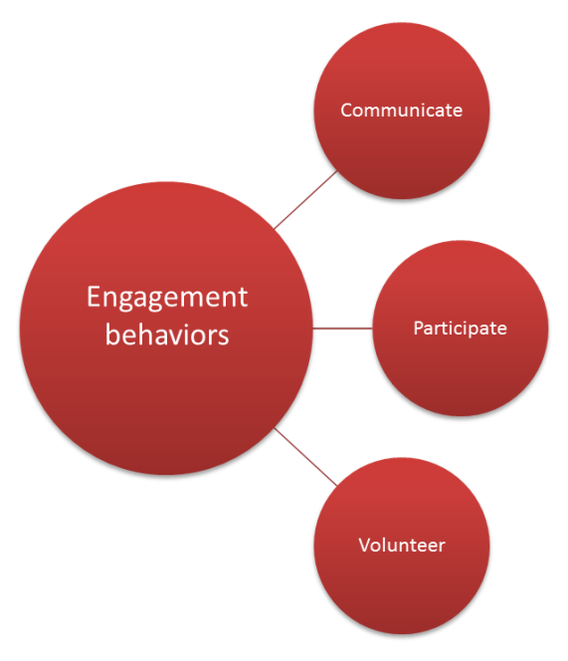
- Communicate examples: contact information updates, reading Harvard Magazine, online community participation, etc.

- Participate examples: local events, Club or SIG membership, reunions, giving, virtual events, etc.

- Volunteer examples: Board service, Schools and Scholarships, Club or SIG leadership, School council leadership, Reunion committee, etc.

In looking at the data and analysis from our engagement research, we determined “Five Areas of Focus” to help drive increased engagement in these behaviors. These are the most important levers in driving engagement. They are:

- Intellectual Content
  - Increase the ability to engage with and share the intellectual riches of the University.
- Campus and Student Connections
  - Connect alumni/ae to students and campus life today.
- Alumni as Insiders
  - Build awareness and access to news about Harvard today and tomorrow.
- Active Citizenship
  - Increase participation in volunteerism and philanthropy.
- Alumni Communities
  - Strengthen and create personal, professional, and intellectual bonds within the alumni community.
Our strategic efforts in these areas of focus should span and encourage all three alumni behaviors: communicate, participate, and volunteer.

Initiatives 2015-2016
Careers and Networking: Alumni to Alumni Networking
Hannah Cardiel AB ’13, Leader
Matthew Temple AB ’86, Leader
Anne Cushing, Staff Liaison

Intellectual Content: Digital and Blended Learning
Ann Koufman-Frederick AB ’78, Leader
Bryan Richards EdM ’97, Leader
Clint Ficula EdM ’11, Staff Liaison

Public Service
Raphael Bostic AB ’87, Leader
Julie Palmer AB ’84, Leader
Joslyn Evans CPC ’11, Staff Liaison

Student and Recent Graduate Engagement
Raine Figueroa AB ’84, MBA ’91, Leader
TBD, Leader
Heather Gain, Staff Liaison

Volunteer Ambassadorship
Danguole Altman AB ’81, Leader
Elisabeth Bentel Carpenter AB ’87, MBA ’94, Leader
Kellie Celia, Staff Liaison

Committees 2015-2016
Awards
Tanya Ryk Friedman AB ’94, Chair
Kate Freed ALM ’11, Staff Liaison

Chief Marshal Selection Committee
Nancy Sinsabaugh AB ’76, MBA ’78, Chair
Courtney Shurtleff, Staff Liaison

Clubs & SIGs: Advancing Clubs and SIGs
Katherine Kennedy AB ’88, Chair
Jonathan R. Aibel AB ’91, Chair
Chandra Mohammed, Staff Liaison

Clubs & SIGs: Data Insight and Strategic Marketing
Amy Hanson AB ’92, Chair
Rita Pang AB ’96, Chair
Lauren Brodsky, Staff Liaison

Committees (cont.)
Clubs & SIGs: Strengthening SIGs
Emily Parrott AB ’09, Chair
Ryan Thoreson AB ’07, Chair
Ryan Ford, Staff Liaison

College Alumni Outreach Committee: Broadening Engagement (Year 26 Through 40th Reunion)
Jonathan London AB ’88, MBA ’95, Chair
Webster O’Brien AB ’86, MBA ’95, Chair
Courtney Shurtleff, Staff Liaison

College Alumni Outreach Committee: Maintaining Connections (Year 41 and Beyond)
Thomas Blodgett AB ’61, MBA ’65, Chair
Ann Giese Porter AB ’62, Chair
Deborah Smullyan AB ’72, Staff Liaison

College Alumni Outreach Committee: Strengthening Foundations (Year 6 Through 25th Reunion)
Vanessa W. Liu AB ’96, JD ’03, Chair
Eli Rosenbaum AB ’05, JD ’08, MPP ’08, Chair
Jack Cashman, Staff Liaison

Committee to Nominate Overseers and Elected Directors
Leila Fawaz AM ’72, PhD ’79, Chair
Kate Freed ALM ’11, Staff Liaison

Happy Observance of Commencement
Thomas E. Black AB ’66, Chair
Kenneth S. Ledeen AB ’67, Chair
Sara Graham, Staff Liaison

Harvard-Cambridge Scholarships
Joshua S. Goodman AB ’00, Chair
Sara Graham, Staff Liaison

Schools & Scholarships
Katherine Williams Fahs AB ’83, Chair
Bryce Gilfillian AB ’12, Staff Liaison

Undergraduate and Alumni Outreach Committee: Building Community (Undergraduate through 5th Reunion)
Jonathan Jeffrey AB ’16, Chair
Ryley Reynolds AB ’15, Chair
John Prince AB ’13, Staff Liaison

