

**Menu Template Instructions (Navigation Bar)**

**Overview**:   
The Menu Template (Navigation Bar) is an excel spreadsheet that details instructions for the navigation bar for your website. The spreadsheet has three columns that represent the main navigation, the sub-menu items and the destinations. It will look something like this:

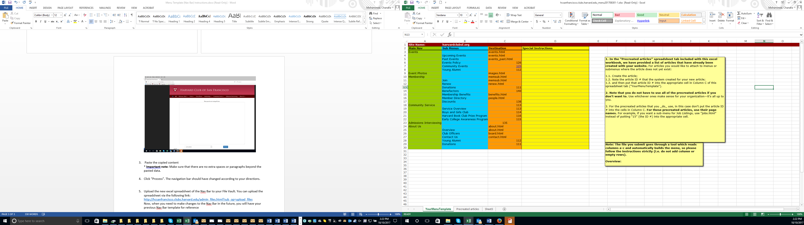

**Column A: Main Navigation:** This is the text that will be displayed in your main menu.  
  
**Column B: Sub Menus:** This column represents all of your submenu items. The submenu is displayed as a drop down from the main navigation. The sub menu consists of links to additional pages on your site. For example, when you roll your cursor over the membership menu, you will see Join, Member Directory, etc.  
  
**Column C: Destination:** The third column instructs the website on where the menu items will point to when a user clicks on the link. The destination of the sub menu items in your navigation bar need to include articles numbers that you have created in “Manage Articles”. AlumniMagnet also has a set of articles that they have added to the site called “pre-created articles”*. For articles that you have created, add in the article number in column c. For pre-created articles*, add the page name of the pre-created article (e.g. “about.html”)

**How to implement Menu changes**:

1. On the excel document, highlight and copy *only* the first 3 columns. Do not highlight any columns past column C – the destination column. It will look something like this:

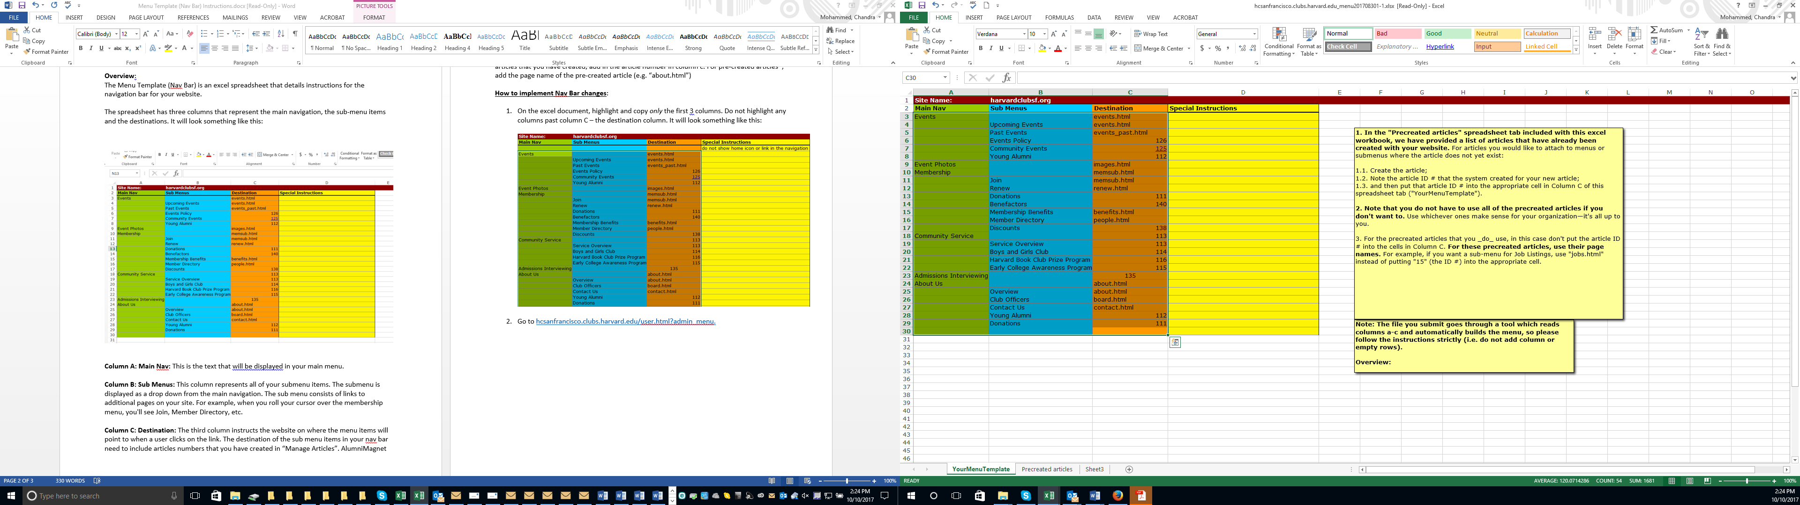

1. Go to <http://hcsanfrancisco.clubs.harvard.edu/user.html?admin_menu>

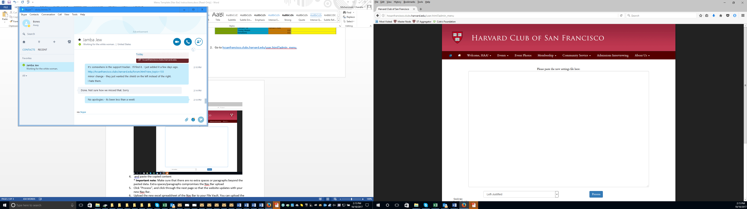

1. Paste the copied content   
   * **important note**: Make sure that there are no extra spaces or paragraphs beyond the pasted data.

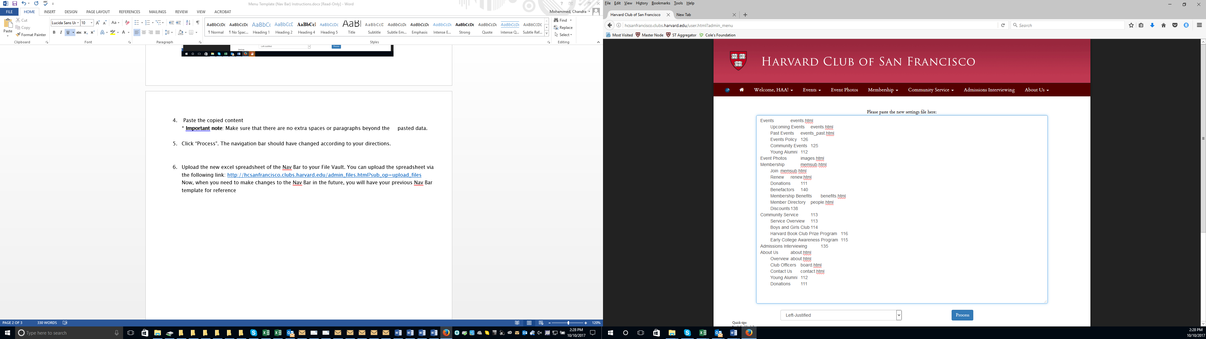

1. Choose if the menu items should be left or right justified.
2. Click “Process”. The navigation bar should have changed according to your directions.
3. Hover over the menu items to make sure the changes took. If anything looks strange, click undo.
4. You are now free to continue with other admin functions.
5. Upload the new excel spreadsheet to Manage Files & Images. When you would like to make another change – just edit the most recent spreadsheet.
6. If you run into any issues – please call 800-654-6494 or email [alumni_magnet@harvard.edu](mailto:alumni_magnet@harvard.edu).